Test Case: runTestMultipleTimes
Step 1 - Enter username and password and click to button Enter : Credentials Entered
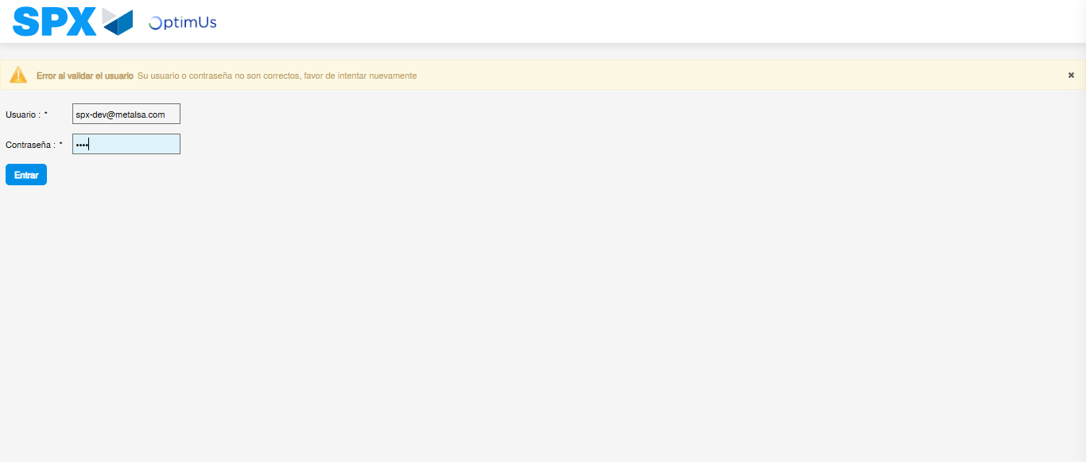Image file-name: QC_Testing-runTestMultipleTimes-dic. 04 2025, 03 39 41 p. m.

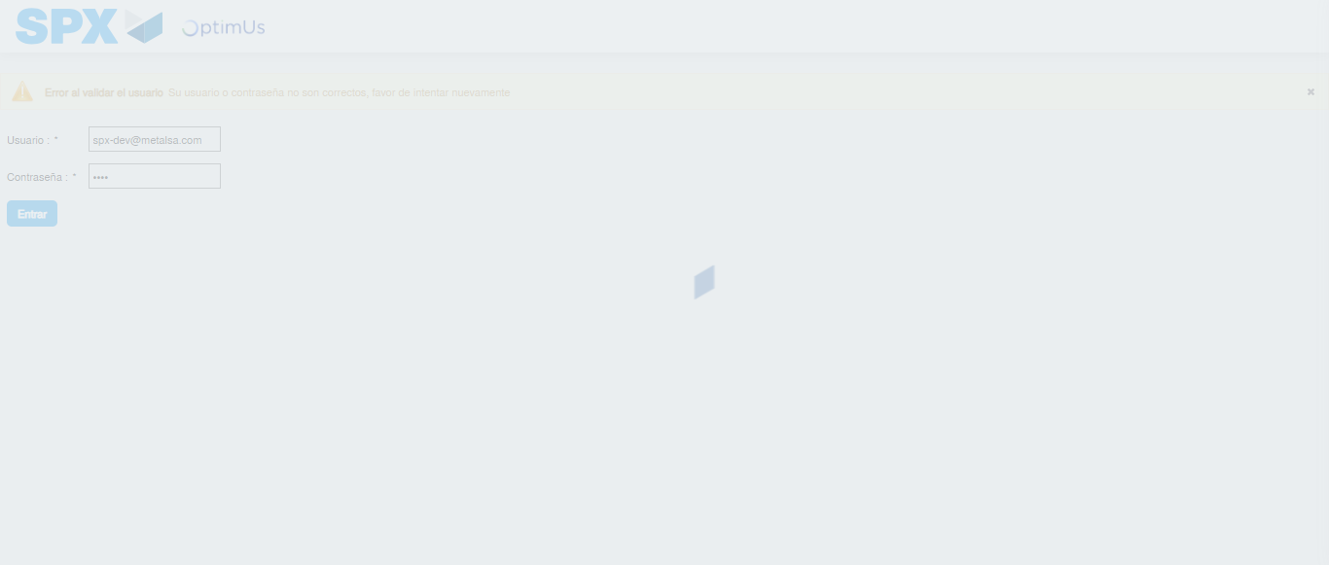Image file-name: QC_Testing-runTestMultipleTimes-dic. 04 2025, 03 39 42 p. m.

Step 2 - Select to UEN and Access to Administrador Roles Menu: UEN Correctly selected and Correct access
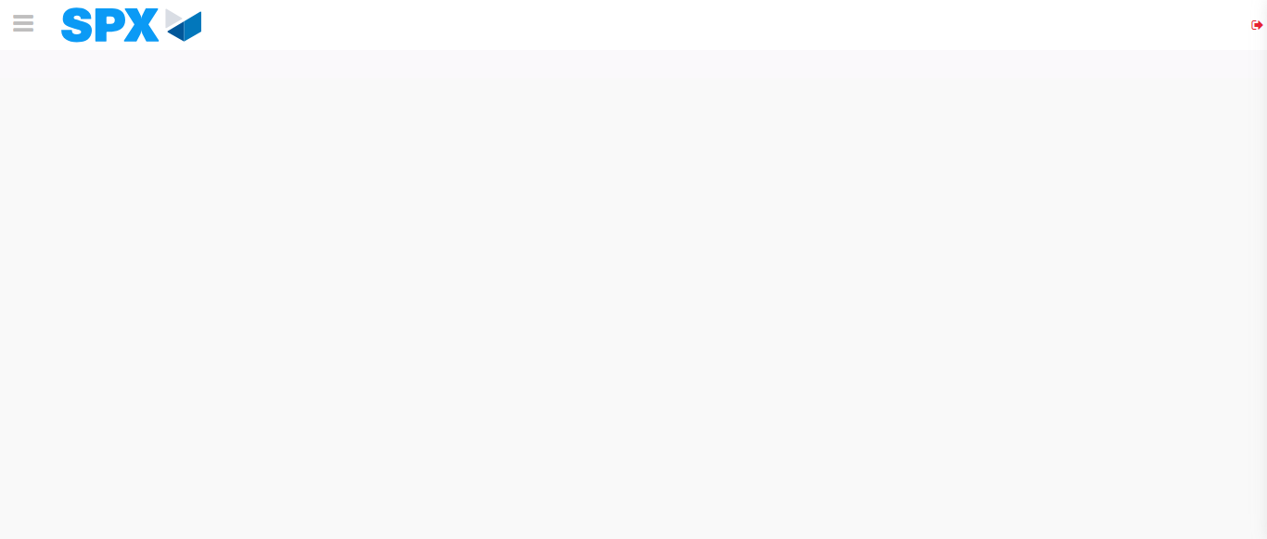Image file-name: QC_Testing-runTestMultipleTimes-dic. 04 2025, 03 39 45 p. m.

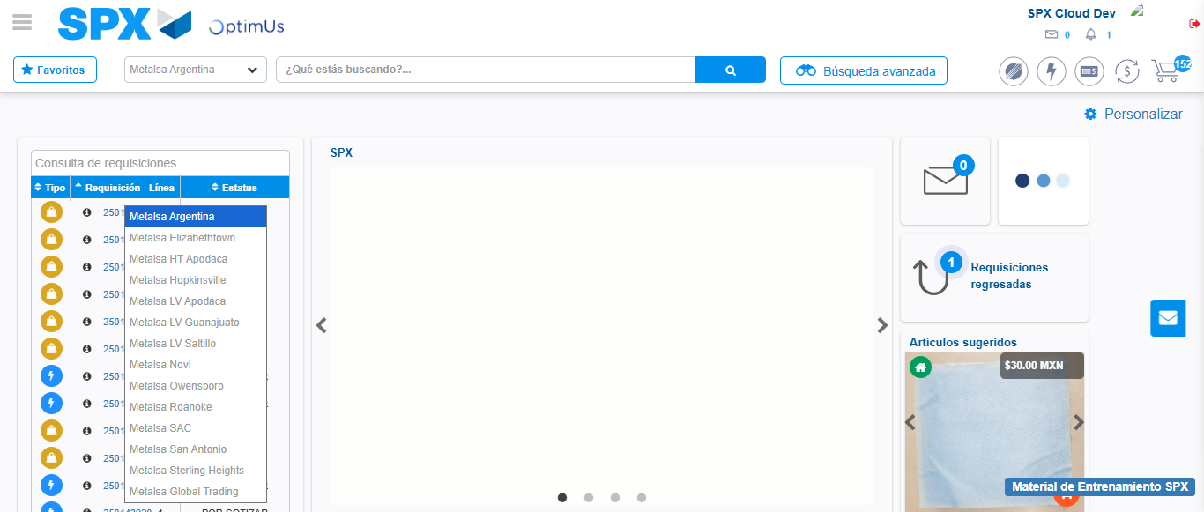Image file-name: QC_Testing-runTestMultipleTimes-dic. 04 2025, 03 39 46 p. m.

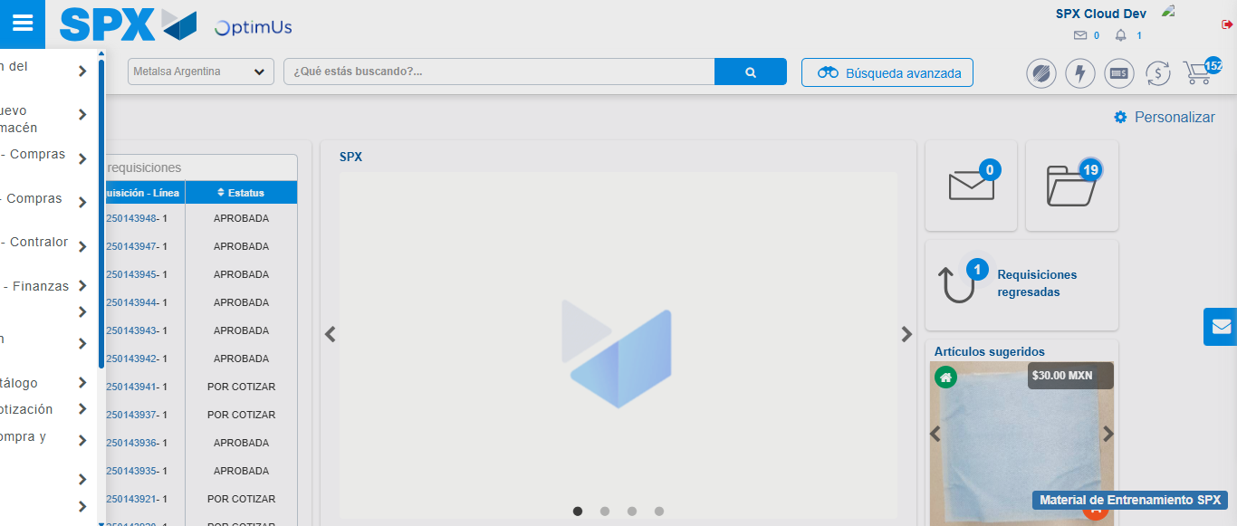Image file-name: QC_Testing-runTestMultipleTimes-dic. 04 2025, 03 39 47 p. m.

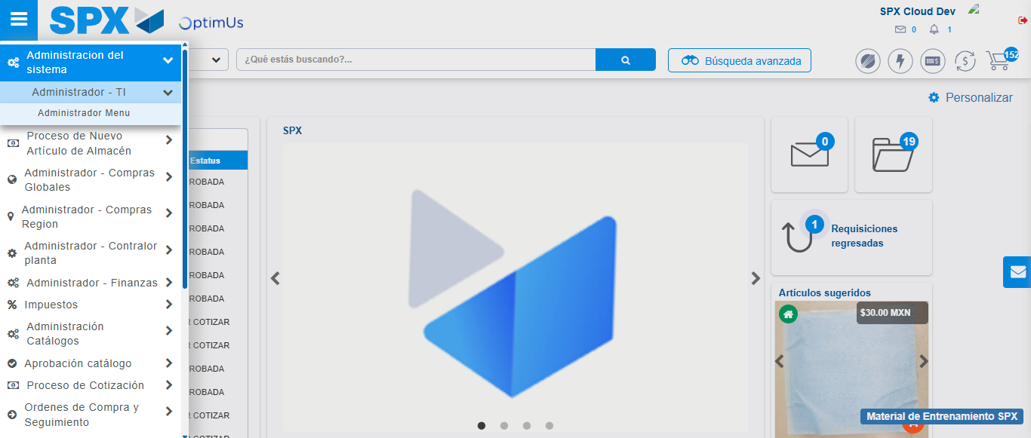Image file-name: QC_Testing-runTestMultipleTimes-dic. 04 2025, 03 39 48 p. m.

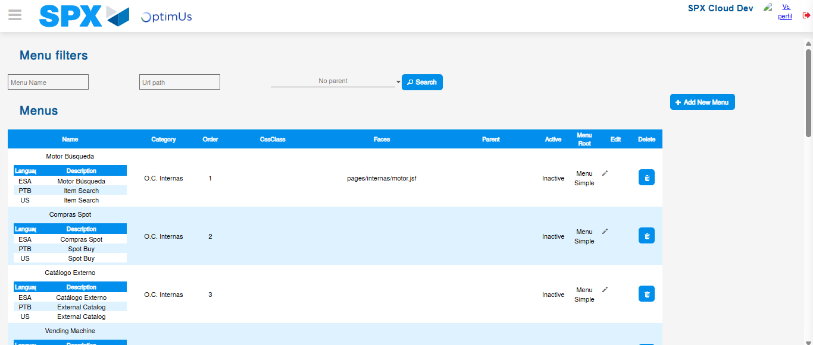Image file-name: QC_Testing-runTestMultipleTimes-dic. 04 2025, 03 39 50 p. m.

Step 3 - Perform a search with the URL Path filter: Successful search
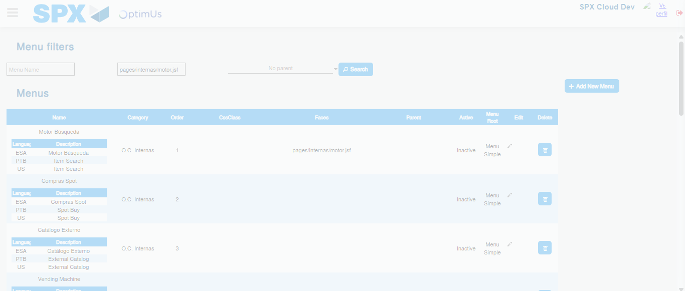Image file-name: QC_Testing-runTestMultipleTimes-dic. 04 2025, 03 39 51 p. m.

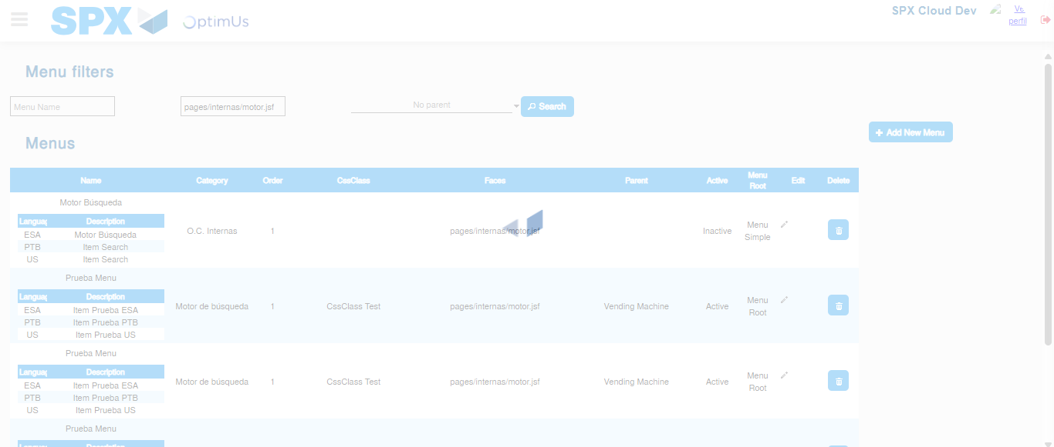Image file-name: QC_Testing-runTestMultipleTimes-dic. 04 2025, 03 39 52 p. m.

